
CPS Mobile Phone Policy
2025
Parents of Pupils attending CPS
As partners in your child’s education, you have an important role in supporting the school’s policy on the use of mobile phones. Equally, we want to support you in protecting your child from the known dangers associated with Smartphones (see Appendix 1)
Our aim is to help strike a balance between ensuring personal safety and the wellbeing for our children. At CPS, we accept and understand that personal mobile phones are often given to children to ensure their personal safety on their journeys to and from school.
Only Year 6 children who walk to / from school independently may bring a phone into school.
In line with our commitment to the Smartphone Free Movement, we will only accept phones without internet access, often referred to as ‘block’ or ‘brick’ phones. Trackers are also allowed.
If you are interested, please join the ‘Claygate Primary School Smartphone Free’ parents WhatsApp group via the website: https://smartphonefreechildhood.co.uk

Mobile Phones at CPS
Parents complete the online form to request permission for their Year 6 child to bring a ‘brick phone’ to school if they walk to /from school unaccompanied.
The head teacher gives permission for the Year 6 child to bring their phone to school.
Year 6 children must sign the CPS Acceptable Use contract before they are allowed to bring a ‘brick’ phone into school.
Year 6 children must switch off their phones on arrival and before they pass through the green gates.
Year 6 children hand in their phone to the teacher until the end of the day, when they will be returned.
Year 6 children may not access or use their mobile phone during the school day.
When Year 6 children have their phones returned to them at the end of the day, they must not switch them on until they have passed the first green gates. They may then safely stand between the two green gates until their phones switch on.

Sanctions
The use of sanctions in school is always seen as a last resort; however, occasions may arise where children may breach the provisions set out in this policy. In these circumstances, new guidance outlines a number of sanctions and powers available to schools when implementing the prohibition of mobile phones in school.
The guidance states that schools have the power to:
- Search a pupil or their possessions where they have reasonable grounds to suspect that the pupil is in possession of a prohibited item - this includes smartphones and other personal electronic devices.
- Confiscate mobile phones or similar devices for a period of time deemed appropriate by the headteacher.
- Enforce sanctions and disciplinary measures, such as ‘time out’ and the removal of certain privileges.
- Inform parents.
When applying sanctions, the school expects all its staff to act in a measured way, considering whether the confiscation or sanction is proportionate and taking into account any special circumstances relevant to the case.
It is important to note that the law protects staff from liability in any proceedings brought against them for any loss or damage to items they have confiscated as a sanction, providing they have acted lawfully.
Staff at CPS
Staff are expected to enforce the school’s policy on the use of mobile phones in school.
Staff sign the school’s acceptable Use agreement and are not be allowed to use personal mobile phones in front of pupils throughout the school day.
Online Safety guidance and information
It is important that all parents and children are aware of the dangers of Internet access and the use of APPS designed for older users.
Children are taught about online safety as a subject in itself and through the wider curriculum including PSHE (Jigsaw Scheme), our Computing Scheme (Kapow) and through events eg Online Safety Week, visits from our local community police officers. Opportunities to reinforce this learning are also seized through assemblies or in response to news events.
What can parents do to help protect children online?
Families play an essential role in protecting children online and there are lots of ways you can help to minimise risk and increase awareness of the online world. To help you start discussing some of the issues relating to internet use, we have listed some of the ways you can do this below:
- Talk to your children about why it is important to stay safe online. Explain that whilst the internet is a fun, exciting and knowledge-rich tool, it is also a place where people may wish to bring them into dangerous activities or expose them to harmful material. It is important to be clear that you are not saying your child may never use the internet again, or that everything on it is harmful – it is about teaching them to have a greater awareness and to be able to manage and report any risks.
- Only give your children devices or access to devices that you feel comfortable with, and not as a result of peer-pressure deriving from their classmates and/or friends who are also using those devices.
- Discuss rules for being online and draw them up together, including which sites, games, etc., are acceptable. If certain games are off-limits, try to explain why – for example, because of excessive violence. If your child uses online gaming, consider setting rules such as only talking to others in the same age range and having the conversation on speaker, rather than headphones, so you can monitor it.
- Discuss what information should be private and what is ok to share; for example, addresses and names. Names should never be given out to strangers online, as this could allow them to identify where your child goes to school or lives.
- Keep an open dialogue with your child – letting them know they can always talk to you about anything that has made them feel uncomfortable online is key to keeping them safe.
- Set parental controls – do this as a dialogue with your child so that they are aware of what they are not allowed to view; however, do not rely on parental controls on devices, as they are not always 100 percent effective, and many children know how to bypass them.
- Make sure your child knows how to report or ‘block’ unsuitable content, messages or people online – show them how to block on the websites or games they frequently use and explain that they can always tell you, a teacher or another adult if they experience anything which makes them feel uncomfortable.
Here are some other resources you can use to help you protect your children online:
NSPCC – ‘Talking to your child about online safety’
https://www.nspcc.org.uk/keeping-children-safe/online-safety/talking-child-online-safety/
Childnet – ‘Have a conversation’
https://www.childnet.com/parents-and-carers/have-a-conversation/
Thinkuknow
https://www.thinkuknow.co.uk/
UK Safer Internet Centre
https://saferinternet.org.uk/guide-and-resource/parents-and-carers

Appendix 1: Risks of Smartphones to children (from Smartphones Free Movement)
Delay Smartphones
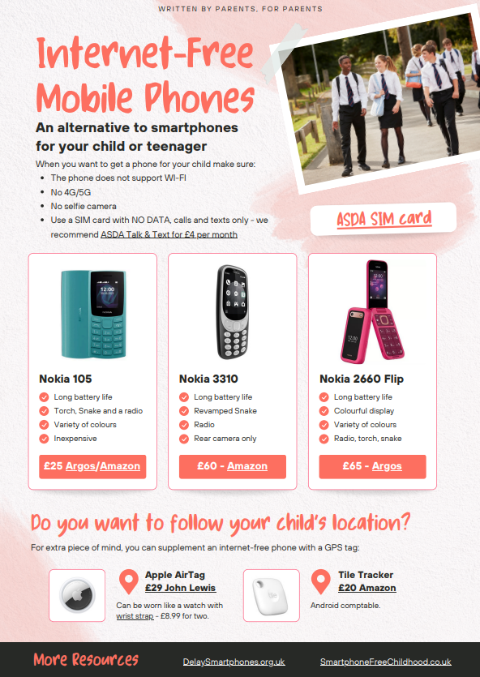
Appendix 2:
* *Prices may vary

