

Welcome to Acorns Nursery

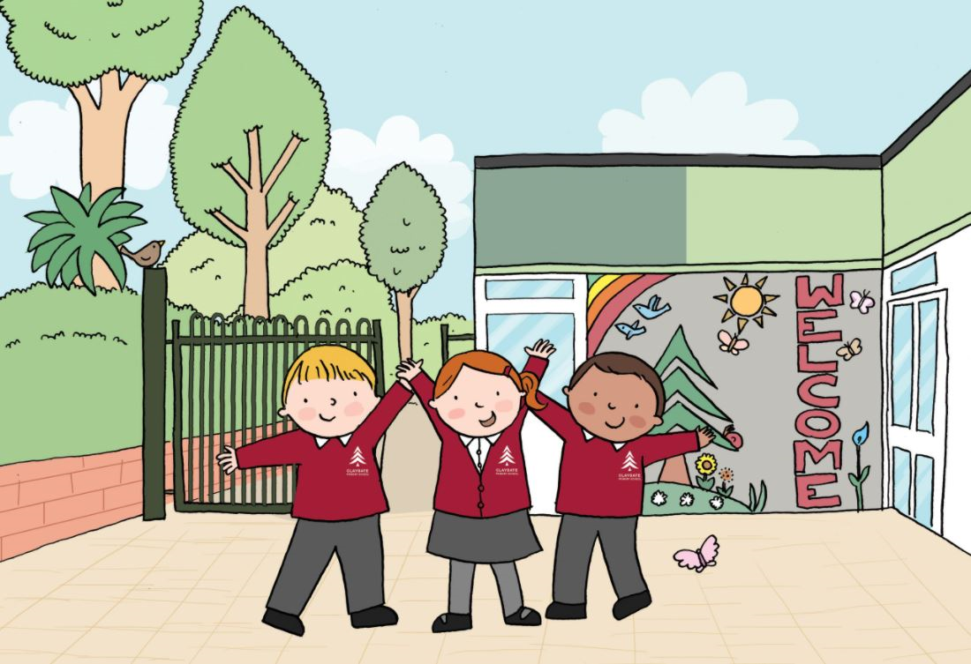.

ACORNS NURSERY ADMISSION FORM

Please complete all sections of this form. If you have any questions please ask a member of the office team who will be pleased to help you.

Please note that the information on this form will be stored securely on the school’s computerised management information system, in accordance with the Data Protection Act and the General Data Protection Regulations (2018)
Details of Child:

Surname: ..............................................................................................................................

First Name ...........................................................................................................................

Middle Name(s): ...................................................................................................................

Gender: Male / Female

Name by which child likes to be addressed (eg Benjamin - Ben) .........................................

Date of Birth: D.................... M........................ Y.....................

How old will your child be on 1 September 2025 …………….. Years …………. Months

Preferred start date:

Autumn / Spring / Summer term Year: …………………………………

(please delete as appropriate)

Child’s home address (this must be the child’s normal place of residence and not a relative
or carer’s address)

Address:
...................................................................................................................................................

..................................................................................................................................................

Post Code: .........................................

Details of Parent(s) / Guardian(s) who has/have actual custody of pupil:

(1) Name: (Mr/Mrs/Other) Forename .............................. Surname …………………………………

Relationship:.......................................

Work Telephone No: ........................................ Mobile Telephone No: ...................................

Email address: ………………………………………………………………………………………….

(2) Name: (Mr/Mrs/Other) Forename .............................. Surname …………………..……………

Relationship:.......................................

Work Telephone No: ........................................ Mobile Telephone No: ....................................

Email address: ………………………………………………………………………………………….

Address: .........................................................................................................................................

Post Code: ......................................... Home Telephone No: .......................................................

Details of other Parent where different and appropriate:

Name: (Mr/Mrs/Other) Forename ………………………………. Surname……………………………

Relationship ……………………………..

Address: ......................................................................................................................................

Post Code: ......................................... Home Telephone No: ....................................................

Work Telephone No: ........................................ Mobile Telephone No: .....................................

Is there a court order in force? Yes / No (delete as appropriate)

If ‘Yes’, please give brief details ..................................................................................................

.....................................................................................................................................................

Admissions Criteria

Please tick under which criterion you are applying for a nursery place

Criterion | Please tick this column
Looked After and Previously Looked After Children

Supplementary information:
Please state which Local Authority and provide evidence with your application

……………………………………………………………………………….

Exceptional circumstances

Supplementary information:
Please state the circumstances and provide evidence with your application

………………………………………………………………………………..

Children who are siblings of children on roll at Claygate Primary School at the time of admission.
Please provide name, DOB and year group as at 1 September 2025

Supplementary information:

- Name……………………………….. Year Group………………..

- Name……………………………….. Year Group………………..

- Name……………………………….. Year Group………………..

Any other Children

Daytime emergency contacts: (In the event of the school being unable to contact either parent, please give details of any adults who could be contacted in an emergency and, if necessary, would be able collect your child from Nursery).

- Name: (Mr / Mrs / Other) .................................................. Relationship:...........................

Address ........................................................................ Tel: ...............................................

- Name: (Mr / Mrs / Other) ...................................................Relationship:...........................

Address ........................................................................ Tel: ...............................................

- Name: (Mr / Mrs / Other) .................................................. Relationship:...........................

Address ........................................................................ Tel: ...............................................

Child’s First Language - A pupil’s first language is defined as any language that a child was exposed to during early development and continues to be exposed to in the home or community. If a child was exposed to a language other than English or to more than one language (which may include English) during early development, that language should be recorded, irrespective of the child’s proficiency in English.

The first language of the child referred to in this form is ……………………………………………

Child’s Home Language (the language most usually spoken at home)

The home language of the child referred to in this form is …………………………………………

Nationality & Country of Birth -  We are required by the DfE to request information regarding your child’s Nationality and Country of Birth as part of the Pupil Census. However, parents are of course at liberty to decide whether or not they provide this information. | Child’s Nationality ……………………………  Child’s Country of Birth………………………

Child’s Religion:

Religion (please specify) …………………………. No religion

Most recent School / Nursery / Playgroup attended:

Name of establishment: ..............................................................................................................

Address .......................................................................................................................................

Period of attendance: From ......................................... to .....................................................

You must provide us with a copy of your child’s birth certificate or valid passport. Please indicate which document you are providing with your application:

Child’s passport
Child’s birth certificate

PREFERRED NURSERY SESSIONS

Preferred session request.
Please indicate below your preferred days. We will try to accommodate your request where we can but the standard 15 or 30 hours will take priority when allocating places.

PLEASE NOTE THAT 15 and 30 HOURS FUNDING CAN ONLY BE USED FOR NURSERY SESSIONS BETWEEN 9am and 3pm. ALL OTHER SESSION TIMES WILL BE INVOICED.

 | Mon | Tues | Wed | Thurs | Fri
AM
9.00 - 12
PM
12 – 3.00

We have the option of 8.45am start and / or 3.15pm finish to align with the school day at an additional weekly charge. Please indicate if you would like to take this option.

YES / NO
.

TREETOPS - Acorns Nursery Wrap Around Care

Treetops Wrap around care is available Monday to Friday during term time for any child attending the nursery. This will provide the children with time to participate in a range of fun, play activities both indoors and outdoors.

The before school session will run from 7.30am with the option of a later drop off at 8am. This includes a breakfast which will be from a selection of toast, cereal, fruit, yoghurt. Breakfast will be served between 8 and 8.30am.

The after school session will run until 6pm with the option of an early pick up at 5pm. This includes a light supper eg. wraps or pitta with a selection of fillings, beans on toast, make your own pizza, sandwiches, fruit and yoghurt. Supper will be served between 4.30-5pm.

Fees will be invoiced on a half termly basis at the start of each half term. If you participate in a childcare voucher scheme please speak with the office for more information.

PREFERRED SESSIONS for Wrap around Care. You will need to book regular sessions in half termly blocks to secure a place. Ad hoc places may bookable subject to availability.

 | Mon | Tues | Wed | Thurs | Fri
Before school
7.30am start
Before school
8.00am start
After school
6pm collection
After school
5pm collection

Please indicate if you will be claiming working parents entitlement for your child. YES / NO
From September 2025, eligible working parents of children aged nine months and above will be able to access 30 hours funded early education and childcare (for 38 weeks a year) from the term following their child turning nine months. The deadline for applying for funding from 1 September 2025 is 31 August 2025. Please apply in plenty of time to avoid any delays in your funding eligibility. You will need to renew every 3 months.

How can I check if I am eligible?
You can check your eligibility for the working parents' entitlement through the Childcare Choices website or by using the Childcare calculator. These will also show if you can get any additional government help with childcare costs.
If you meet the eligibility criteria for the entitlement you should also qualify for Tax-Free Childcare, which can be used to help pay for any additional childcare costs. You can apply for this and the working parent's entitlement at the same time through the Childcare Choices website.
If you already have an eligibility code please provide the following information for the person who has applied:

Parent name

Postcode

NI Number

Tel. number

Email address

Eligibility code

Parent / Carer Declaration

I wish to apply for a place at Acorns Nursery School and I have indicated the criterion under which I am applying for that place. I certify that I am the person with parental responsibility for the child named in Section 1 and that the information given is true to the best of my knowledge and belief. I understand that if I give false or deliberately misleading information on this form and / or any supporting documents, or withhold any relevant information, this may lead to withdrawal of an offer of a nursery school place for my child. I understand the school reserves the right to amend its provision of nursery.

Name of parent / carer ……………………………………………………………………..

Signature of parent / carer …………………………………………………………………

Date …………………………………………………………..

Acorns Nursery Terms and Conditions
(2025-2026)

Name of Child: ________________________________________
DOB: _______________________________________________

Admission information
To apply for a place please complete and sign the Admissions form and Nursery Terms and Conditions form.

We are a term time only Nursery.

Working parents
Parents are responsible for reconfirming their eligibility code for working parents entitlement childcare every 3 months, at least two weeks before the validity end date. Parents must do this, even if nothing has changed, to ensure the code remains valid.
If a code is no longer valid, your child’s place will become parent funded and you will be invoiced for all hours attended until a further valid code is provided.

Fees and Invoices
Fees are set by the Governors of Claygate Primary School and reviewed annually.
Nursery fees are payable half termly. Invoices will be sent in advance and must be paid by bank transfer / online banking within seven days of receipt. Please use your child’s name as a reference, so we are able to match payments and children. Payment plans may be arranged in consultation with the School Office if required.
Timely payments are essential so that the Nursery, which is financially independent from the school, can properly budget for its own expenditure.
Late payments (after seven days of the invoice) incur a £10 administration charge. Children may be excluded from nursery or hours reduced to funded hours only if fees remain unpaid after 14 days.

Fees: Additional Hours
Extra days and sessions may be available. These are booked directly with the School Office in advance in half termly blocks at the sessional charge above.
The Nursery cannot guarantee continued availability of additional sessions Additional ad hoc sessions may be booked subject to availability on a first come, first served basis. Payment must be received in advance to secure the sessions.

Fees: Refunds
The Nursery will not reimburse fees for days when a child was scheduled to attend nursery but is unable to because of their own illness or other circumstances beyond the Nursery’s control (for example: family taking a holiday, Nursery closure due to extreme weather circumstances, Nursery closed due to industrial action).
The Nursery will not change or refund any bookings for additional hours once the term has started.

Fees: Late collection
Failure to collect a child on time will result in a charge to cover staff and nursery costs as follows: a charge of £5.00 for every part or full 15 minute period. A willingness to forego such fines on one occasion will not affect the future right to revert to the above policy. Excessive lateness on a regular basis may result in the registration being terminated.

Cancellation
The Nursery require half a term’s notice in writing if you wish to cancel your place. This notice period is necessary to ensure that we can effectively manage our staffing and resourcing. If a start date is delayed the Nursery reserves the right to charge from the original date stated on the admission form and may reallocate the place.
The Nursery reserve the right to terminate a place with immediate effect if a parent, carer or child displays abusive, threatening or otherwise inappropriate behaviour. The Nursery will give half a term notice in writing if the place is to be terminated for any other reason.
If a child does not take up the place the Nursery reserves the right to charge for that half term. If a start date is delayed the Nursery reserves the right to charge from the original date stated on the admission form. If there is a delay in starting the Nursery may reallocate the place.

Opening Times
The Nursery is open during term time only and will be closed on INSET days. The last day of each term will be an early closure at 3.15pm with the option to collect children earlier at the same time as siblings in the main school.
Please see school website for term dates and INSET days.

Lunches
Children attending a full day may bring a packed lunch or hot meals are available to order via Parentmail on a half termly basis. Please see catering leaflet on the school website. Some children may be eligible for Free School Meals subject to verification of entitlement to Early Years Pupil Premium.

Personal Property and Belongings
Please ensure that your child’s clothing is clearly labelled and all personal toys, books and equipment are left at home.
Parents of children who are not fully potty trained must ensure that there are sufficient disposable nappies and wipes in their child’s kit bag each day alongside a change of clothing.
The nursery cannot be held responsible for any loss or damage to a child’s property or belongings.

Safety and Wellbeing
The Nursery reserves the right to administer first aid and any emergency treatment as required. Parents will be informed of all accidents and asked to sign an accident record form.

As per CPS Policy, parents may be required to collect their child in the event of illness or an accident. If a child has had sickness or diarrhoea the school have a 48 hour exclusion policy from the last bout of illness.
Parents must inform the Nursery of any medical condition, health problem or allergy affecting the child. Parents must inform the Nursery of any significant change in the family circumstances which might affect the child.

Collection by others
The Nursery will only release children to their parent or nominated adult unless informed otherwise. Please inform the School Office of any changes.

Absence
Please inform the school office (via email/ phone call) if your child will be absent due to any illness on each day they will not be attending. If you know in advance that your child will not be attending Nursery on a particular day, please inform the office, as it may then be possible to offer this as an additional session to a parent who requires it.

Agreement
These Terms and Conditions represent the agreement and understanding between the parents (including other carers) and the Nursery. We reserve the right to update / amend these Terms and Conditions at any time. One month’s notice will be given of any changes made.

I have read and understand the Terms and Conditions and agree to be bound by them.

Name of parent: ____ _____________________________________

Signature of parent: _________________________________________

Date: ____________________________________________________

Medical Information

In the event of an emergency, permission is granted for (child’s name) ..........................................
to be taken to hospital and any medical treatment as advised by qualified personnel administered.

He / she is allergic to .................................................................................................................

Family Doctor’s Details:

Name: Dr. .................................... Address: ............................................................................

Telephone No: .............................................

Medical Information (eg allergies etc):

Immunisation Record:

Dietary Information/Any other Information which may be helpful:

The following permission is to cover the total duration of any child attending Acorns Nusery School, and applies to both normal attendance and any Educational Visit and trips away from the school:

I wish my child (child’s name) ............................................................................................. to be allowed to take part in school visits. I certify that as far as I am aware my child is medically fit to undertake visits. I authorise medical treatment to be provided should this become necessary during the course of any visit.

I understand that those supervising my child are in loco parentis and must exercise a standard of care that would be expected of a reasonably prudent parent. The Local Authority will not be responsible for personal injury or any other damage or loss unless it is negligent.

Please give details if your child suffers from any medical condition which, whilst not affecting his / her ability to undertake journeys, you consider the School should be aware of :

I will notify the school of any future change in my child’s health.

Signature of Parent / Guardian .......................................................... Date ............................

Animal handling

Pets have been shown to help children develop social skills, social responsible and help self-esteem. Regular contact with animals has also been shown to help children concentrate, show more cooperation and make them calmer.

The hygiene and safety aspect for our pets and the children is very important to us. The school have completed a risk assessment for looking after our pets and what to do in case of an injury. This information can be found on the CPS website.

We are asking you to inform us of any allergies or if you would rather your child did not take part, please kindly let us know.

I agree / do not agree for my child to take part in activities directly relating to on site and visiting pets.

Parent Signature: __________________________________________________________

Known Allergies: ___________________________________________________________

Prescribed Medication Needed* : ________________________________________________

* I agree to supply this prescribed medication to the school and will contact the school office to
arrange this.

Ethnic background: (based on the National Population Census ethnic categories)

Our ethnic background describes how we think of ourselves. However, ethnic background is not the same as nationality or country of birth.

Please study the list below and tick ONE BOX ONLY to indicate the ethnic background of your child..

Asian or Asian British
Bangladeshi □
Indian □
Pakistani □
Any other Asian background □

Black or Black British
African □
Caribbean □
Any other Black background □

Chinese □

Mixed
White and Asian □
White and Black African □
White and Black Caribbean □
Any other mixed background □

White
British □
Irish □
Gypsy Roma □
Traveller of Irish Heritage □

Any other White background
White European □
Other White background □

Any other ethnic background □

I do not wish an ethnic background category to be recorded □

(Any information you provided will be used solely to compile statistics on the school careers and experiences of pupils from different ethnic backgrounds and will help us to support all our pupils in the most effective way. These statistics will also be passed on to the Local Authority and the Department for Education (DfE) to contribute to local and national statistics. The information will also be passed on to future schools, to save it having to be asked for again. However, this information will not allow individual pupils to be identified publicly).

Photograph Consent: Conditions of Use and General Information

Including images of pupils in displays, publications and on the school website can be motivating for pupils and provides a good opportunity to promote the work of the school. We regularly receive positive feedback about the way in which photos on the website and around the school illustrate our work, and we hope, therefore, that you will feel able to give your consent to the use of photographs in this way. We would encourage you to look at the school website and Twitter to get an idea of how photos are used.

Photographs are taken in accordance with DfE and Surrey guidelines, and in line with data protection guidelines and GDPR. Procedures are followed to ensure that images are used appropriately.

As a general rule, if we use a photograph of a child, we will not include their full name in the accompanying text or photo caption. Similarly, if a child is named in the text, we will not usually include a photograph of that child. There may be occasional exceptions to this, for example if including the child’s name is particularly relevant and appropriate (e.g. if it relates to personal achievement).

We will never include specific personal details on the website (full names, addresses etc).

From time to time, the press may attend an event at school and take photographs for publication. Copyright for these images rests with the photographer and / or the specific media organisation, and they are also the data controller. Local newspapers may wish to include children’s names if it is relevant to do so.

For annual class and individual photographs, where the photographer has been commissioned by the school, copyright rests with the photographer.

Name of child (block capitals):

Name of person responsible for child:

Please tick the relevant box(es) below to confirm your consent | Yes | No
I understand that images of my child may be taken and used as follows:

- By the school in publicising its work, e.g. through the school website and in printed publications

- By the local media in covering school activities that show the school and children in a positive light. These may include drama and musical performances, sporting events, new Reception children etc.

- By photographers acting on behalf of the school, for use in displays and other publicity material, and in annual class and individual photos

- On Social Media sites (Twitter, Facebook, Instagram)
- On Class Dojo or other internal media that may be shared amongst the school community and families
There may be other circumstances, falling outside the normal day-to-day activities in school, in which pictures of children are requested. The school recognises that in such circumstances specific consent from parent / guardian may be required before the school can permit filming / photography of children.

Signature of person responsible for the child:
Relationship to the child:
Date:

Home-School communication using Parentmail

We use Parentmail, an electronic system which enables us to contact parents by text message and e-mail. The majority of correspondence is sent by Parentmail.

For parents, the latest version of ParentMail means you can easily pick up school messages on your phone by downloading the free ParentMail App on Android or iOS.

- No need to search through your busy personal inbox for school messages.
- Instant access – no need to login to complete forms or read messages.
- In app notifications help make sure things do not get missed or forgotten.

To use the latest version of ParentMail all you need to do is verify your account. Please complete the form below and you will then be sent either an email or text message from ParentMail; when you receive this please just follow the instructions below.

If you have both a mobile number and an email address registered on your account, you will receive a registration invitation by text and email. You can decide which way you register – but you will only need to register once.

Mobile registration:
Please click on the link from the text message and follow the verification process. You will be asked to enter some details to verify who you are and to set a password for your account.

Email registration:
Please click on the link from the email and follow the verification process. As above, you will be asked to enter some details to verify who you are and to set a password for your account.
Please be assured that ParentMail is registered with the Information Commissioner and guarantees that all information you provide will be kept private and will not be passed on to any other organisation.

If you have any issues or queries with the process please contact a member of the school office team.

Parent 1
E-mail address……………………………………………………………………………………………

Mobile number……………………………………………………………………………………………

Signature of parent/carer ……………………………………………………………………………….

Parent 2
E-mail address……………………………………………………………………………………………

Mobile number……………………………………………………………………………………………

Signature of parent/carer ……………………………………………………………………………….

