
Child Protection at Claygate Primary School



Our Safeguarding and Child Protection Team are:
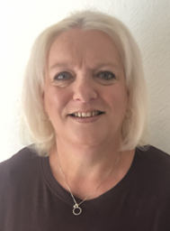
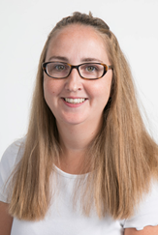
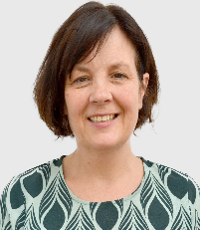
Mrs Marita Cunniffe
DDSL

Mrs Susan Minter
DDSL
Mrs Hilary Ali
DSL
Mrs Kim Waters
Clubhouse DSL
Mrs Sandra Cunningham
DDSL

Any member of staff, volunteer or visitor to the school who receives a disclosure of a safeguarding concern, abuse, hears an allegation or suspects that abuse may have occurred must report it immediately to Hilary Ali (DSL) or in her absence, the Deputy Designated Safeguarding Leads (DDSL), Sandra Cunningham, Marita Cunniffe, Susan Minter and Kim Waters. For any concerns about a member of staff working with a child, you must report this to the Headteacher, Sandra Cunningham.

Please do not delay in reporting any concern

Role | Name | Telephone Contact | E-mail
Designated Safeguarding Lead (DSL) | Hilary Ali | 01372 465348  Ex 206 | Hilary.ali@claygate.surrey.sch.uk
Deputy Designated Safeguarding Lead (DDSL) | Sandra Cunningham | 01372 465348 Ex205 | Head@claygate.surrey.sch.uk
Deputy Designated Safeguarding Lead (DDSL) | Marita Cunniffe | 01372 465348  Ex204 | Marita.cunniffe@claygate.surrey.sch.uk
Deputy Designated Safeguarding Lead (DDSL) | Susan Minter | 01372 465348 | Susan.minter@claygate.surrey.sch.uk
Claygate Clubhouse Designated Safeguarding Lead | Kim Waters | 01372 423411 | Kim.waters@claygate.surrey.sch.uk
Co-Chairs of Governors | Meryl White  Simon Tanner |  | Meryl.white.gov@claygate.surrey.sch.uk  Simon.tanner.gov@claygate.surrey.sch.uk
Designated Person Recruitment | Sandra Cunningham | 01372 465348  Ex205 | Head@claygate.surrey.sch.uk
Safeguarding Governor | Nez Zein |  | Nez.zein.gov@claygate.surrey.sch.uk

Key Contacts within the Local Authority

Agency | Name | Telephone Contact | E-mail
Single point of Access (CSPA) | Screening Officer | 0300 470 9100 | cspa@surreycc.gov.uk
Children’s Emergency Duty Team | Duty Person | 01483 517898 | edt.ssd@surreycc.gov.uk
Local Authority Designated Officer (LADO) | Duty Person | 01372833342 | LADO@surreycc.gov.uk

