

Parent, Carer, Volunteer and Visitor
Home School Agreement and Code of Conduct
Part 1

Status & Review Cycle | Statutory Annual
Written by Sandra Cunningham | September 2018
Shared with Governors | September 2025
Next Review Date | September 2026

*This policy applies to anyone accessing the school site

CPS Home School Agreement
At Claygate Primary School (CPS) we value our sense of community. We believe a supportive partnership between home and school is essential if children are to thrive emotionally and academically. At CPS, we therefore strive to build a strong relationship with families to help create a stimulating learning environment that continues from school to home, providing all pupils with the opportunity to achieve to the best of their ability.
To create a welcoming and safe learning environment, CPS implements a specifically designed set of rules, reflective of our ethos and values regarding behaviour and conduct which families are expected to act in accordance with.

Legal framework
This document has due regard to all relevant legislation and statutory guidance including, but not limited to, the following:
- Education Act 2011
- Education Act 1996
- Children Act 2004
- DfE (2024) ‘Keeping Children Safe in Education’
- DfE (2018) ‘Controlling Access to School Premises’
CPS children agree to:
I attend Claygate Primary School and I agree to:

- come to school every day and on time
- be smart, wearing my school uniform (or PE kit on appropriate days)
- always work hard and try my best to learn at school and at home and not prevent the learning of others
- follow instructions given to me by any member of staff respectfully and promptly
- demonstrate both the British Values and our CPS Values at all times
- follow our school rules, reflecting on them if I make the wrong choices
- keep myself and others safe
- Follow the Acceptable Use Agreement
- take good care of the building, equipment and school grounds
- tell a member of staff if I am worried or unhappy

Uphold our CPS Values and our British Values and follow our school rules:
- We strive to be safe and healthy.
- We show courage in our learning and in our choices.
- We try hard to achieve our best.
- We respect each other and adults.
- We are responsible, honest and polite.
- We are friendly and care for each other.
All children are supported to:
- Be a ready learner.
- Be resilient, work hard and always try your best.
- Display a growth mindset, not afraid to make mistakes.
- Reflect on what you have learnt and think of ways to improve it next time.
- Behave sensibly and responsibly online.
- Embrace all the school has to offer – get involved in clubs, activities and events.
- Be proud of the achievements of others and celebrate their successes.
- Understand that bullying is not tolerated.
CPS Parents / Families agree to:
By sending your child to our school, I agree to the Home School Agreement. I will:

- ensure my child has good attendance, is punctual with the correct CPS uniform
- conduct myself in an appropriate fashion in and around the school site
- treat all members of our school community with respect
- respectfully raise concerns or worries promptly and directly with the school
- raise any safeguarding concerns immediately with a member of the DSL Team
- attend meetings and read school communications
- support CPS Values by encouraging my child to develop a positive attitude towards the CPS community and beyond
- accept the school’s aims, policies and procedures
- use digital technology appropriately without placing myself or others in the school community at risk, including NOT filming/recording meetings without consent, taking photos etc without permission and when permission is given, not sharing said images on social media.
CPS Parents and Visitors agree to:
- Act in accordance with relevant school policies and procedures at all times
- Help keep the school environment safe eg no dogs on site; reporting any issues that might be considered a health and safety risk
- Set a good example to pupils through their behaviour and the way they interact with staff, pupils and other adults.
- Treat all governors, staff members, pupils, other parents and any members of the school community with dignity and respect.
- Respect the school’s property and environment by keeping it clean and tidy.
- Respect the confidentiality of other children and families. We cannot share details of incidents involving other children. All concerns will be addressed appropriately, but information about others will remain private.
- Follow the school’s procedures for dropping-off and collecting pupils from school, driving and parking according to the highway code and respecting our neighbours
- Dress in an appropriate manner when on the school premises and attending school events
CPS Staff agree to:

- provide a safe and happy environment where all children are listened to, valued and respected
- provide excellent teaching and an engaging curriculum to help your child reach their full potential and become independent learners
- provide opportunities beyond the curriculum through Enrichment, clubs and trips
- provide regular updates on your child’s social, emotional and academic progress.
- achieve high standards of behaviour by developing positive social relationships, self-esteem and a sense of responsibility in line with the school’s ethos, CPS Values and British Values and professional standards
- support your child to develop a moral and ethical compass for life enabling them to grow up to be the best person they can be
- teach your child to develop a positive attitude to others, regardless age, disability, gender reassignment, race, religion or belief, sex, marriage or civil partnership, pregnancy and maternity (protected characteristics)
- treat all information about children and families with care. Ensure it is stored securely and shared only in line with statutory responsibilities, safeguarding requirements, and to support normal school functions.
- provide information to you about our school and events in a timely manner.
CPS Governors agree to:
- Behave in a professional manner, as set down in the governing body’s code of conduct, including acting in strict confidence.
- Ensure the school fulfils its legal and statutory requirements eg safeguarding, finance, processing and use of data etc.
- Monitor and analyse the school’s performance and support and challenge the leadership team to continually improve it.
- Set the strategic aims of the school in line with our vision to help children excel at learning, express their talents, and care for others.
- Ensure they know the school’s strategic aims, its strengths and key areas of improvement to meet them.
- Act at all times in the best interest of all the pupils of the school.
- Respect the confidentiality of children, families, staff and school business and will not discuss individual children, families or sensitive staff matters outside of official meetings.
- Use information to support governance duties only and in line with statutory responsibilities.
- Appoint senior leaders in the school and hold them to account for the school’s performance.
- Oversee the financial performance of the school and making sure its money is well spent.
- Attend relevant training to allow them to effectively fulfil their responsibilities as a governor.

Parents, Carers, Volunteers and Visitors
Home School Agreement and Code of Conduct
Part 2

*This policy applies to all visitors to the school site

CPS Code of Conduct
Contents:
- Inappropriate behaviour
- Managing inappropriate behaviour
- Barring from the school premises
Appendix:
https://www.gov.uk/government/publications/controlling-access-to-school-premises

Introduction

Claygate Primary School is a nurturing learning community. We believe children learn best in a safe and supportive environment based on respect and trust, underpinned by an effective partnership between staff, pupils, parents, carers, volunteers, visitors and the whole school community.

High standards of behaviour are required of children and staff are expected to act professionally. The positive support of our families is highly valued and expected by the school. Incidents that this policy relate to are thankfully extremely rare and CPS is particularly fortunate to have such a strong and invested community to support its role in providing high quality and inclusive education for all children who attend our school. In common with many organisations, our aim with this code is simply to set out some clear and concise guidelines that are easily understood by all.

This ‘Parents, Carers, Volunteers and Visitors Code of Conduct’ has been adopted and agreed by the school’s Governing Body. It provides a reminder to all parents, carers, volunteers and visitors to our school about the conduct expected of them. It sets out both what they should aim to do and conduct which will not be tolerated. This is so we can continue to flourish, progress and achieve in an atmosphere of mutual understanding and respect.

This code complements the school’s ‘Complaints Policy’ which is designed to manage parental concerns or complaints in a sensitive and mutually supportive manner (please see the school website, or contact the school office).

Schools are private property. People do not have an automatic right to enter a school site. Parents have an ‘implied licence’ to come on to school premises at certain times, eg to drop off or pick up children, to attend meetings or school events. (This includes those acting in ‘loco parentis’ eg a designated adult, nanny or other relative.)

Schools may also welcome others onto the site, including workmen, specialist teachers, peripatetic teachers, tutors, volunteers and those delivering workshops.
All parents will be provided with a link this code of conduct upon their child’s attendance at the school and are required to familiarise themselves with the procedures and guidelines outlined.

Inappropriate behaviour
The school takes instances of inappropriate behaviour seriously and will not tolerate any circumstances that may make children, staff members and other members of the school community feel threatened.
Parents and Carers are expected to:
- Respect the safety and security of the school by not trespassing, breaching security procedures or driving/parking unsafely on school grounds.
- Treat all members of the school community; pupils, staff, governors and visitors with respect and courtesy at all times. This includes, but is not limited to:
  - Avoiding raising voices inappropriately, using offensive language or making aggressive gestures.
  - Not discriminating, bullying, harassing, intimidating or threatening anyone, including verbally, physically or online.
  - Not sending abusive, aggressive or threatening communications (see Appendix 1).
- Respect school property by not causing intentional damage.
- Avoid behaviour that disrupts school operations or activities, including approaching other parents or pupils to discuss or reprimand them.
- Follow school rules regarding clothing, smoking, vaping, alcohol and illegal or harmful substances.
- Seek permission before taking photographs or recordings on the school site and do not post images online without consent.
- Refrain from writing or posting abusive, offensive or defamatory comments about the school or individuals online.

Managing inappropriate behaviour
Step 1
  - If a visitor is behaving inappropriately, a report will be made to the Head Teacher (or the most senior member of staff available in their absence), who will decide on the most appropriate course of action and will not approach the visitor themselves.
  - Instances of visitors displaying inappropriate behaviour will be managed in a variety of ways, depending on the severity of the situation.
Step 2
- If a visitor has behaved inappropriately, they may be invited to a meeting with the Head Teacher to discuss their behaviour in an attempt to resolve the issue.
Step 3
- Where this initial meeting is not sufficient to resolve the issue, the Head Teacher, in collaboration with other staff and relevant agencies, will consider what further action may be required.
This action, depending on the situation, could include the following:
- Restricting channels of communication to the school, e.g. no longer allowing a parent to send emails to a staff member directly
- Reporting content posted online to the website’s admin
- Referring the case to children’s social care, where the behaviour indicates that the parent poses a risk to children
- Contacting the police
- Barring the visitor from the school premises
- Seeking legal redress through the courts
*Any child protection and safeguarding concerns will be addressed in accordance with the school’s Child Protection and Safeguarding Policy.
Step 4
Behaviour that could result in a visitor being asked to leave the premises is outlined above and includes aggressive, abusive or insulting behaviour or language that is a risk to staff or pupils or behaviour which makes staff or pupils feel threatened.
The school reserves the right to escort anyone off the premises who is displaying aggressive or disruptive behaviour.
The police may be contacted to provide advice on managing an incident or to assist in the removal of an individual from the premises, where necessary. The police will be contacted where a visitor is being violent or has committed assault or where the event has caused harm to an individual.
If a visitor has been previously barred from the premises or has exceeded their implied access to the premises and is causing a disturbance, the police may be contacted to remove the individual from the premises.
If a visitor displays unacceptable and inappropriate behaviour or persistently does so, they may be barred from the school premises, in line with the Barring from the School Premises section of this policy.

Barring from the School Premises
If there is a one-off incident of extremely inappropriate behaviour on the school site, or a visitor persistently or consistently behaves inappropriately, the school reserves the right to bar this individual from the school site to keep the school community safe.
Throughout this process, confidentiality is maintained and any investigations and evidence gathering will be handled sensitively and with confidentiality in mind.
- The school may bar the visitor temporarily until the visitor has had the opportunity to formally present their side or any further necessary investigations are undertaken.
- The Head Teacher will notify the visitor via email / letter, informing them why they have been temporarily barred (or may potentially face a longer bar pending their representation), inviting them to a meeting.
- Meeting the visitor: the Head Teacher will inform the visitor of the following information:
- Why they have been temporarily barred or face a bar
- The nature of the bar, i.e. if they are temporarily barred pending their representation
The visitor will then be invited to present their side and share any other pertinent evidence
- After meeting the visitor, the Head Teacher will consider the visitor’s presentation and any other evidence shared. Factors considered may include: implied licence, the severity of the incident, those impacted by the incident and potential future impact should the visitor continue to access the site.
- The circumstances and next steps will be presented and discussed with the Chair of Governors.
- The Head Teacher and Chair of Governors may seek advice from the LA Area Schools Officer.
- The Head Teacher will then share the outcome of the decision with the visitor:
  - a ‘potential future bar’ notification letter / email may be sent notifying the visitor that a possible bar may be considered should there be future breaches as outlined within this policy
  - a ‘temporary bar’ may be considered. The duration and areas on the school site included within the bar will be determined. Decisions to impose a temporary bar will be reviewed at the end of the agreed timescale, in line with the process outlined above. Following a review, the bar may be lifted or, if there are grounds for continued concern regarding the visitor’s conduct, it may be extended.
  - a bar may be considered
- Appeal: The visitor has the right to appeal and formally express their views on the decision to bar in writing to the Chair of Governors within 10 working days
- The Chair of Governors will take account of any representations made by the barred visitor and decide whether to confirm or lift the bar. The visitor will be notified in writing, explaining:
- The Chair of Governor’s decision
- And, if appropriate, how long the bar will be in place and the end of the bar review date.
Once the appeal process has been completed, a visitor who remains barred may be able to apply to the Civil Courts. If a visitor wishes to exercise this option, they will be advised to seek independent legal advice.

Monitoring and review
This document will be reviewed annually by the Head Teacher and any changes made will be communicated to all parents and staff at the school. By visiting the site, parents, carers, visitors and volunteers are agreeing to this Code of Conduct.

Appendix 1 Inappropriate Use of Social Media and Communications Platforms
Social media platforms, including communications platforms such as WhatsApp are used increasingly to raise complaints or issues against schools. The Governors consider the use of social media and communications platforms in this way as unacceptable and not in the best interests of the children or the whole school community.
Any issues you may have must be made through the appropriate channels by speaking to the class teacher, the Head teacher or the Chair of Governors and following the school complaints policy so they can be dealt with fairly, appropriately and effectively for all concerned.
Libellous or defamatory posts
In the event that any school staff, pupil, parent, carer, volunteer or visitor is found to be posting libellous or defamatory comments on social media or group communications about the school, they will be reported to the appropriate ‘report abuse’ section of the platform.
All social media platforms have clear rules about the content which can be posted on the platform and they provide robust mechanisms to report content or activity which breaches this. The school will also expect that such comments would be removed immediately.
Cyber bullying
We take very seriously the issue of cyber bullying by any member of staff, pupil, parent, carer, volunteer or visitor to publicly humiliate another by inappropriate social media use and will treat it as a serious incident of school bullying. Thankfully such incidents are extremely rare. In serious cases the school will also consider its legal options to deal with any such misuse of social media platforms.

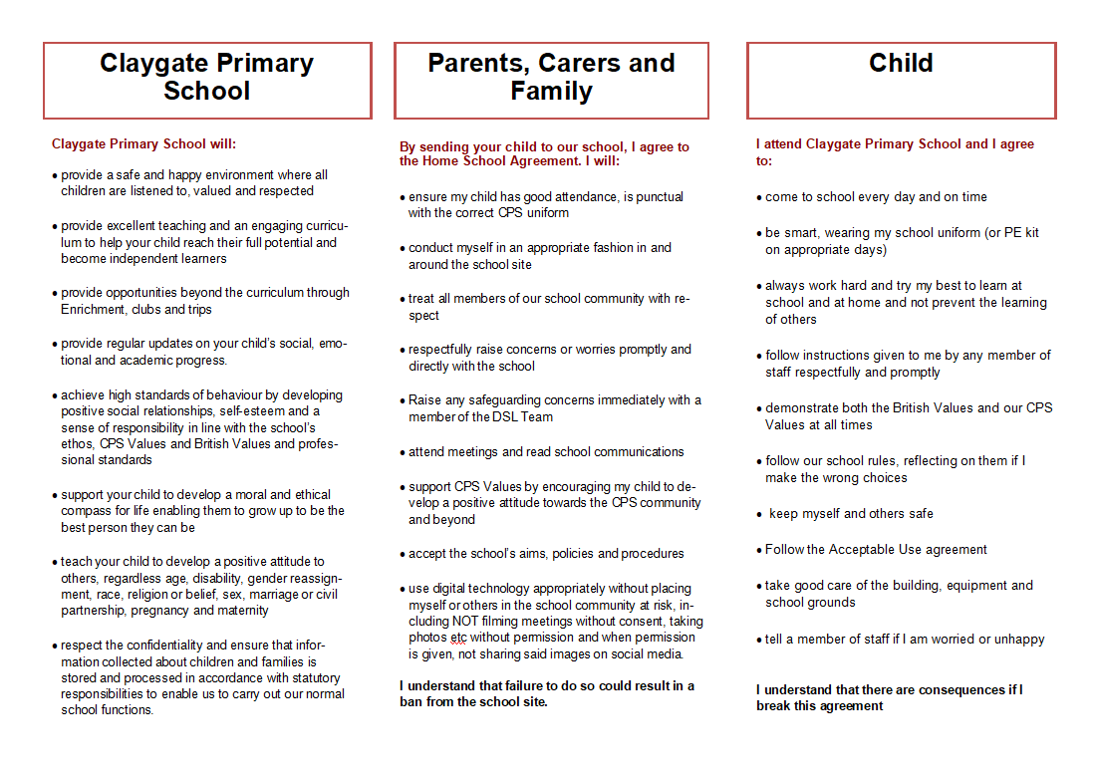
Appendix 2: Home School Agreement Leaflet

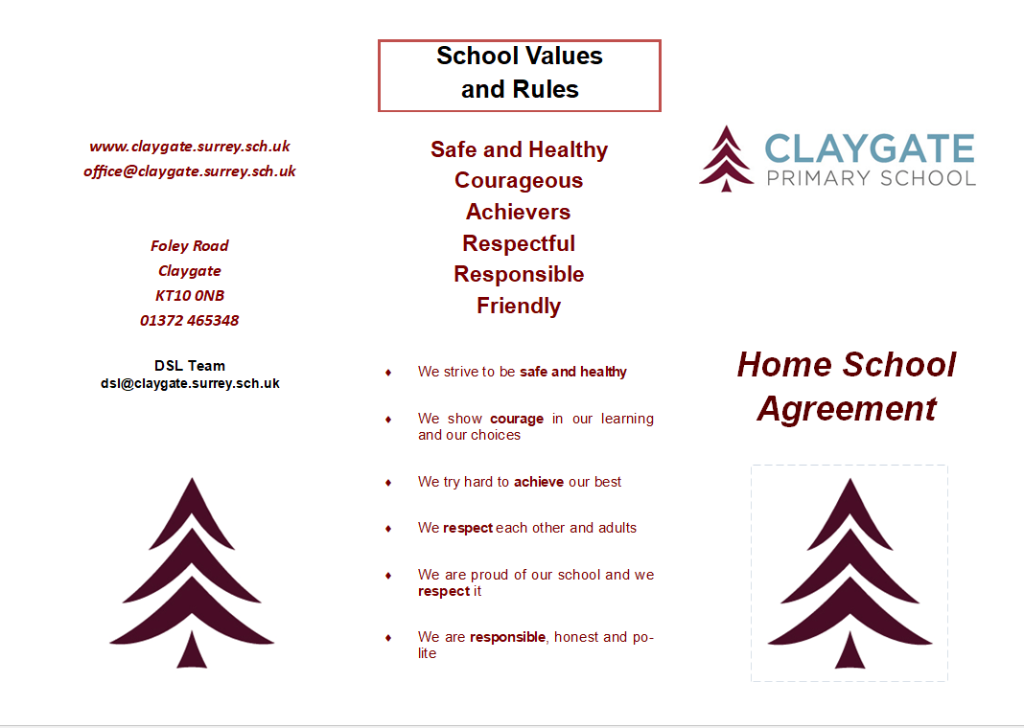

DfE: Controlling Access to School Premises (Nov 2018)
https://www.gov.uk/government/publications/controlling-access-to-school-premises
- Who can go onto school premises?

Schools are private property. People do not have an automatic right to enter. Parents have an ‘implied licence’ to come on to school premises at certain times, for instance:

- for appointments
- to attend a school event
- to drop off or pick up younger children
Schools should set out their rules for this and tell parents what they are. Anyone who breaks those rules would be trespassing.
- Barring individuals from school premises

Trespassing is a civil offence. This means that schools can ask someone to leave and take civil action in the courts if someone trespasses regularly. The school may want to write to regular trespassers to tell them that they are potentially committing an offence.
Schools can bar someone from the premises if they feel that their aggressive, abusive or insulting behaviour or language is a risk to staff or pupils. It’s enough for a member of staff or a pupil to feel threatened.
The school should tell an individual that they’ve been barred or they intend to bar them, in writing. Letters should usually be signed by the headteacher, though in some cases the local authority, academy trust or proprietor may wish to write instead. The individual must be allowed to present their side. A school can either:
- bar them temporarily, until the individual has had the opportunity to formally present their side
- tell them they intend to bar them and invite them to present their side by a set deadline
After the individual’s side has been heard, the school can decide whether to continue with barring them. The decision should be reviewed within a reasonable time, decided by the school.
The Department for Education (DfE) does not get involved in individual cases.
3. Removing individuals from school premises
Section 547 of the Education Act 1996 makes it a criminal offence for a person who is on school premises without legal permission to cause or permit a nuisance or disturbance. Trespassing itself does not constitute a criminal offence.
To have committed a criminal offence, an abusive individual must have been barred from the premises or have exceeded their ‘implied licence’, then also have caused a nuisance or disturbance.
If a school has reasonable grounds to suspect that someone has committed an offence, then they can be removed from the school by a police officer or a person authorised by the appropriate authority such as the:
- governing board
- local authority
- proprietor of that school

